Dragons from Dragon tales

Ord (<https://dragontales.fandom.com/wiki/Ord>

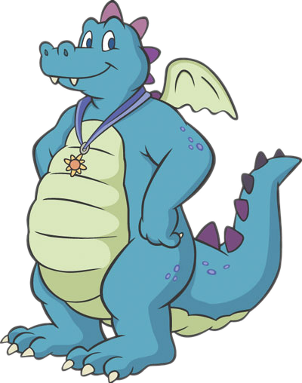

Jake long (<https://adjl.fandom.com/wiki/Jake_Long>

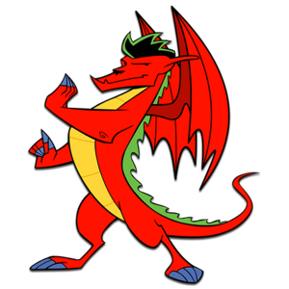

Drogon (game of thrones) <https://www.harpersbazaar.com/culture/film-tv/a27522097/game-of-thrones-drogon-iron-throne-reactions/>

